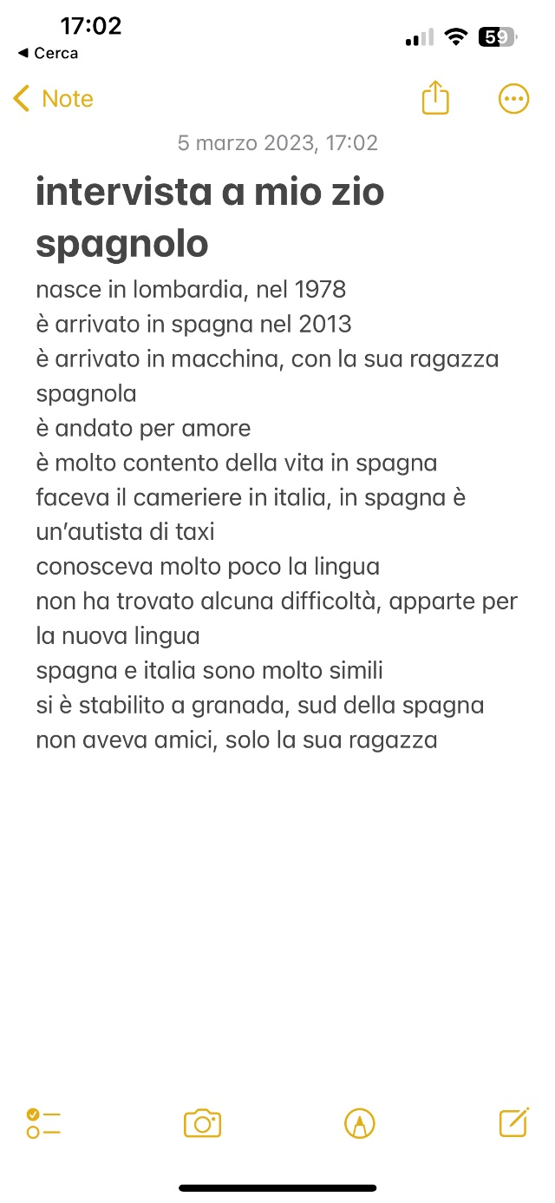

<https://app.Lumi.education/run/wBula2>